1. **How many burgers were ordered?**

select count(*) as "No. of Orders" from runner_orders;



1. **How many unique customer orders were made?**

select count(distinct customer_id) as "No. of Unique Customers " from customer_

orders;



1. **How many successful orders were delivered by each runner?**

select runner_id, count(order_id) as "Successful Orders"

from runner_orders

where cancellation is NULL

group by runner_id;

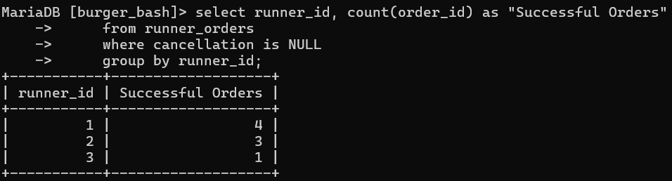

1. **How many of each type of burger was delivered?**

SELECT p.burger_name, COUNT(c.burger_id) AS Delivered_burger_count

FROM customer_orders c

INNER JOIN runner_orders r ON c.order_id = r.order_id

INNER JOIN burger_names p ON c.burger_id = p.burger_id

GROUP BY p.burger_name;

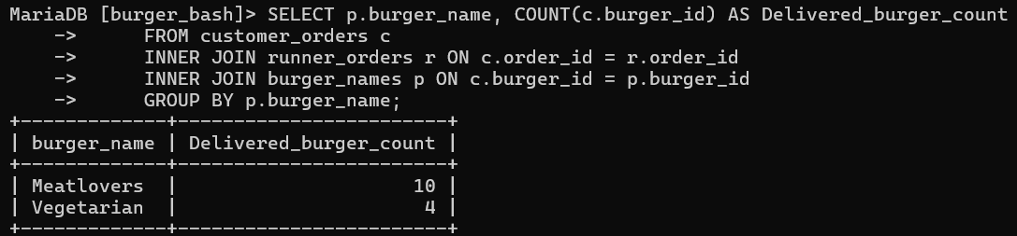

1. **How many Vegetarian and Meatlovers were ordered by each customer?**

select c.customer_id,b.burger_name , count(b.burger_name) as "No. of Orders"

from customer_orders c

inner join burger_names b

on c.burger_id = b.burger_id

group by c.customer_id, b.burger_name;

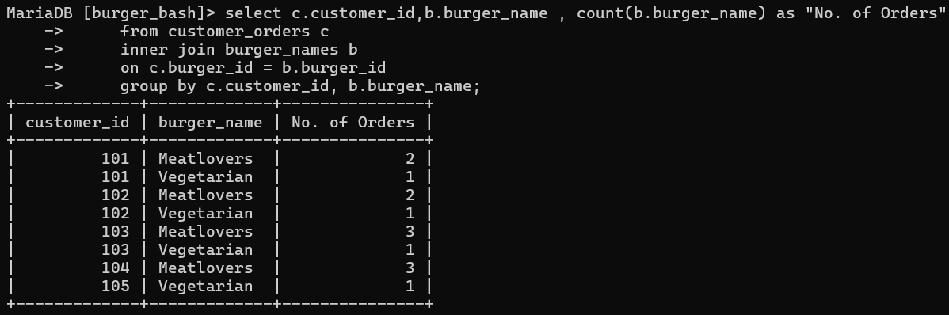

1. **What was the maximum number of burgers delivered in a single order?**

WITH burger_count AS (

SELECT c.order_id, COUNT(c.burger_id) AS Burger_per_order

FROM customer_orders c

INNER JOIN runner_orders r ON c.order_id = r.order_id

WHERE r.distance != 0

GROUP BY c.order_id

)

SELECT MAX(Burger_per_order) AS burger_count

FROM burger_count;

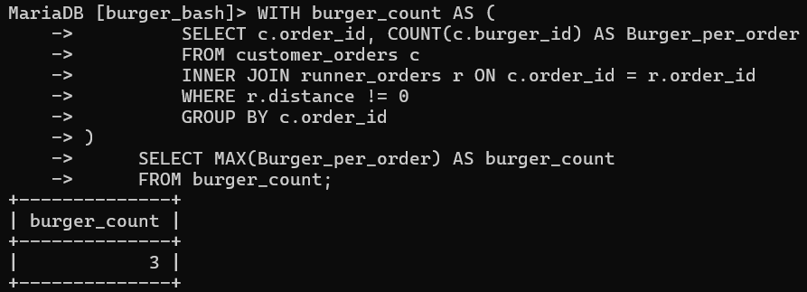

**7.What was the average distance travelled for each customer?**

select c.customer_id, avg(r.distance) as Average_distance

from customer_orders c

inner join runner_orders r

on c.order_id = r.order_id

where r.duration!=0

group by c.customer_id;

